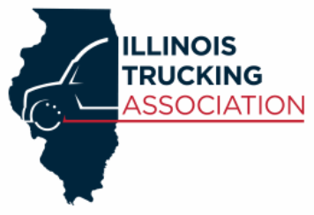
SAFETY AND MAINTENANCE
COUNCIL MEETINGS

Illinois Trucking Association is introducing a new council designed for the safety and maintenance professionals, operations, human resource, dispatch and executives. These meeting will supply the attendees with time to network, keynote speakers, information regarding the transportation industry, (i.e. regulations, what we can expect in the future and what are some of the challenges we face when trying to maintain a positive image).
Each quarter ITA will host a meeting, with a guest speaker. The first meetings are on the ITA calendar for you to get the time reserved.
THERE IS NO CHARGE!!!! What are you waiting for register today and mark your calendars?

March 12, 2019 – Dan Meyer, FMCSA Division Administrator
ITA office, 2250 S Chicago St., Suite 201, Joliet, IL 60436
5:30-7 p.m. Food will be served.
Or
March 26, 2019 - Dan Meyer, FMCSA Division Administrator
Truck Centers Training Facility, 2280 Formosa Rd, Troy, IL 62294
5:30-7 p.m. Food will be served.

Use the registration below and email to linda@iltrucking.org or visit the ITA website under events and register through the link provided, or Fax 217-544-4206.

_________________________________________ ______________________
Name Phone

_________________________________________ _______________________
Company email

Please select the meeting you will attend Joliet ________ or Troy ________

